

**T.C DOĞUŞ ÜNİVERSİTESİ**

**ENGINEERING FACULTY**

**COMPUTER ENGINEERING**

**Media Streaming Website**

**COME 491 PROJECT**

**PREPARED BY**

**Marwan Elsabie**

**20180301093**

**Imad Al Khawam**

**20190301539**

**MOHAMAD KARBEJHA**

**20180301125**

**ADVISOR**

**Dr. Öğr. Üyesi BİRSEN GÜLDEN ÖZDEMİR**

**İSTANBUL, February 8th 2022**

PREFACE

First of all, we would like to would like to thank our advisor Birsen Gulden Ozdemir for her assistance during the process of making this project and for her valuable guidance.

We would like also to thank our instructors of our department for the precious knowledge that they provided for us during the past last 4 years.

Finally, we would like to thank our families and friends for their support during our university years.

İstanbul, February 8th 2022 Marwan Elsabie

Imad Al Khawam

Mohamed Karbejha

SUMMARY

In order to give the user a better chance and experience to deal with fast and secured website for streaming multiple media content. we built this website with the goal to provide easy interface for the user.

Keywords: Media, Users, Admin, Pages, Easy

ÖZET

Kelaniya birden fazla medya içeriği akışı için hızlı ve güvenli web sitesiyle başa çıkma konusunda daha iyi bir şans ve deneyim sağlamak için. Bu web sitesini, kullanıcı için kolay bir arayüz sağlamak amacıyla oluşturduk.

Anahtar Kelimeler: Medya, Kullanıcılar, Yönetici, Sayfalar, Kolay

CONTENTS

PREFACE i

SUMMARY ii

ÖZET iii

CONTENTS iv

LIST OF FIGURES vii

LIST OF TABLES viii

SYMBOLS ix

ABBREVIATIONS x

REQUIREMENTS ANALYSIS DOCUMENT 1

1. INTRODUCTION 1

1.1. Purpose of the system 1

1.2. Scope of the system 1

1.3. Objectives and success criteria of the project 1

1.4. Definitions, acronyms, and abbreviations 1

1.5. References 1

1.6. Overview 1

2. CURRENT SYSTEM 2

3. PROPOSED SYSTEM 3

3.1. Overview 3

3.2. Functional requirements 3

3.3. Nonfunctional requirements 3

3.3.1. Usability 3

3.3.2. Reliability 3

3.3.3. Performance 3

3.3.4. Supportability 3

3.3.5. Implementation 3

3.3.6. Interface 3

3.3.7. Packaging 3

3.3.8. Legal 3

3.4. System models 3

3.4.1. Scenarios 3

3.4.2. Use case model 3

3.4.3. Object model 3

3.4.4. Dynamic model 3

3.4.5. Database model — ER diagram 3

3.4.6. User interface—navigational paths and screen mock-ups 3

4. GLOSSARY 4

PROJECT BUDGET AND TIME PLAN 5

5. INTRODUCTION 5

5.1. Gantt Chart 5

5.1. Project Budget 6

5.2. Project Phase Distribution 6

5.3. Other Tables 7

PROJECT SPECIFIC CONTENT 7

6. INTRODUCTION 7

6.1. ACCESSIBILITY 7

6.2. USER MANUAL 7

6.3. TEST PLAN 7

6.4. MAINTENANCE PLAN 7

CONCLUSION AND DISCUSSION 8

REFERENCES 9

APPENDIX 10

BIOGRAPHY 11

LIST OF FIGURES

Figure 5.1 Gantt chart sample 1 5

Figure 5.2 Gantt chart sample 2 made with excel 5

LIST OF TABLES

Table 5.1 Project budget table 6

Table 5.2 Project phase distribution 6

SYMBOLS

β Sample Test Phase

ABBREVIATIONS

VS Visual studio

DB Database

REQUIREMENTS ANALYSIS DOCUMENT

# INTRODUCTION

## Purpose of the system

The main purpose of this system is to provide the internet users with the ability to access media content easily and free of charge, the website will have many options for the user to choose from while also enabling them to save it with ease.

## Scope of the system

Aims to deliver the user with a simple interface to navigate from.

without prior knowledge of the website

## Objectives and success criteria of the project

User satisfaction with the website streaming servers, No Ads to bother the user and complete security for the user information, and a controlled content suitable for all different ages.

## Definitions, acronyms, and abbreviations

Definitions, acronyms, and abbreviations are located at page ix.

## References

References are located at section “REFERENCES” on page 15.

## Overview

# CURRENT SYSTEM

Normally the systems on most of the web that support media streaming doesn’t have many functions that personalize the user experience like many websites the user dose not have the choice to create an account and without an account he can’t access his past watch history. Also, the current websites contain too much advertisements sometimes with unproper content for many ages.

So, we decided to add some functions to make the website user friendly, for example we added an option to create an account, then the user can access his recent watching history, in addition to make the website more secure we decided to control all the unproper content.

# PROPOSED SYSTEM

## Overview

## Functional requirements``

. You can easily create an account and login in to the website using your unique account in the homepage you have the option to make adjustments to the account, update information, delete account.

And while navigating the main homepage you can search for the desired content through: name, genre, released year, also you can download the media

## Nonfunctional requirements

The system runs mainly on php code while the interface is being styled by CSS and bootstrap

The system uses MySQL for the DB.

It holds the username, last name, and email, password, date of birth, and phone number in the DB

### Usability

The website requires basic knowledge of the internet usage so its useable for everyone

### Reliability

The website is very reliable when the servers are working and running

The user can access the website and browse flawlessly

### Performance

According to our tests, it runs smoothly on 3 different laptops and 3 different phones

### Supportability

The website supports any smart device with an access to web browsers

Egg: phones, laptops, gaming consoles, iPads, smart fridges.

### Implementation

The system is coded using Visual studio code and MySQL

### Interface

The website has different user interfaces like homage, sign up, sign in, media streaming page, and user panel page, admin panel page

### Packaging

### Legal

## System models

### Scenarios

### Use case model

### Object model

### Dynamic model

### Database model — ER diagram

### User interface—navigational paths and screen mock-ups

Sign up page

* Sign up page

The website simply starts with the sign-up page, where you're required to enter your data to register it in the database.

The user will be asked to enter a Name, mobile number, email address and a password, and a birthdate.

Information should be unique and not repeated or else the user won’t be able to sign up

Log in page

* After signing up the user will be directed to the login page where he will enter his information, and if the login is successful the user will be directed to the homepage

* Home page

-After the log-in is successful the user will be directed to the homepage where he can search and choose for media to watch

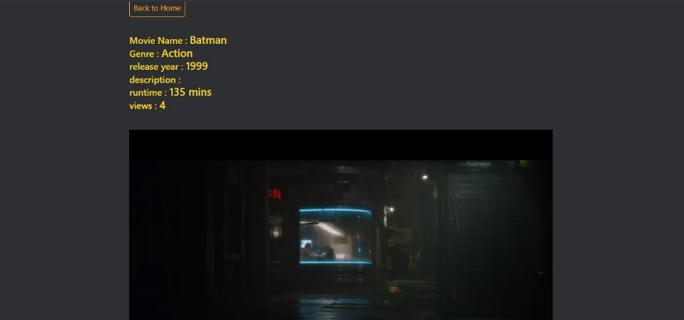

* The movie pages

-Here the user will watch the media that he selected or he can have the choice to download it directly.

-All necessary information about the media will be shown in the page.

# GLOSSARY

PROJECT BUDGET AND TIME PLAN

# INTRODUCTION

A project plan is one of the most important ingredients for a successful project. It is used to document and communicate expectations, to control schedule and delivery, and to calculate and manage risks. In general, it acts as a roadmap for everyone involved in the project.

## Gantt Chart

Figure ‎5.1 Gantt chart sample 1

sample 2 made with excel

## Project Budget

The project didn’t require any budget since we are working on a local host and the coding software is free.

## Project Phase Distribution

In this section, calculate the percentage from Gantt chart.

Table ‎5.1 Project phase distribution

|  |  |  |  |
| --- | --- | --- | --- |
| **Planning & Analysis** | **Design** | **Implementation** | **Testing** |
| %45 | %25 | %25 | %5 |

## Other Tables

-Above is the advisor meetings schedule.

PROJECT SPECIFIC CONTENT

# INTRODUCTION

## ACCESSIBILITY

The website is designed to provide easy access to media watching and is user friendly.

## USER MANUAL

* The website simply starts with the signup page, where you're required to enter your data to register it in the database.

1. After signing up the user will be directed to the login page where he will enter his information, and if the login is successful the user will be directed to the homepage

1. After login the user will access the home page which he can search for movies or watch his recent watching history .

1. When the user picks his movie, he will be directed to movies page where he can stream it

4- Above the user can enter his control panel where he can change his username and password

## TEST PLAN

So far, the website has been tested only on a pc and 2 laptops.

The tests have been positive so far but further traffic needs to occur for more accurate results

## MAINTENANCE PLAN

CONCLUSION AND DISCUSSION

IN the end and after our continuous efforts and with the help of our advisors and instructors

We have been able to build and design and Finish the website successfully with every function Running without any issues , the website will deliver the user with a convenient time saving experience , the user will be able to create an account and access the website to browse the rich library of media content , the user can also save time and search for his desired content , while also providing the user with the download option and a fast servers to stream from .

All in all, we are delivering the ultimate user experience with our website.

Lastly, we would like to thank our instructor Birsen Gulden Ozdemir for her support and her precious guidance, also we would like the make a special thanks to our instructor dry Zahid Garbo for his invaluable knowledge form his web development course which helped us throughout our coding process.

REFERENCES

1. YouTube
2. Stack overflow
3. Dogus web programming lectures.

APPENDIX

To DOU Students Streaming website

The project was coded on Visual studio using php and css and MySQL for the database design

The workload was divided, but not much was logged to know exactly who did what, so we can safely say that the project was a collective effort, almost no feature was done entirely by one team member. Here is a gnat chart showing how the work was planned to be divided among us, but we had to reconsider that because not everything went according to plan.

-Above is the development process we used during our project building stages

It’s the waterfall method which is the classical way of working on project

We found it most suitable for us because it requires to finish each stage before moving to the following one which in turn made it easier for us to focus our efforts to each stage.

BIOGRAPHY

**Marwan Elsabie:** I have been coding since 4 years to be honest. but I like coding and i feel interested about web development and design i wish all the success in my future career .

**Imad Al Khawam:** I’m a fourth year computer engineering student in dogus university, my main interests are web development and block-chain technology , I’m planning to become a dedicated block chain developer in the future because I believe in keeping up in the new age technology and moving forward.

**Mohamed Karbejha:** I'm in 27th year old, I live in Turkey from 4 years ago, I'm working in IT Company, actually it is making my dream real ability. I like coding and troubleshooting skills in computer, and I hope to graduate and being computer engineer and improve my skills in computer.